Interactive Demo FOLIO:

Creating a login

https://bugfest.folio.ebsco.com/
folio/folio

Preparation Steps
1. Click on the User Icon in the Upper Right

2. Click on New in the upper right hand corner

3.Fill out the basic user information.
User Name________________
Password _________________
Use a real email address that you have access to.
My Barcode is _____________
Click save

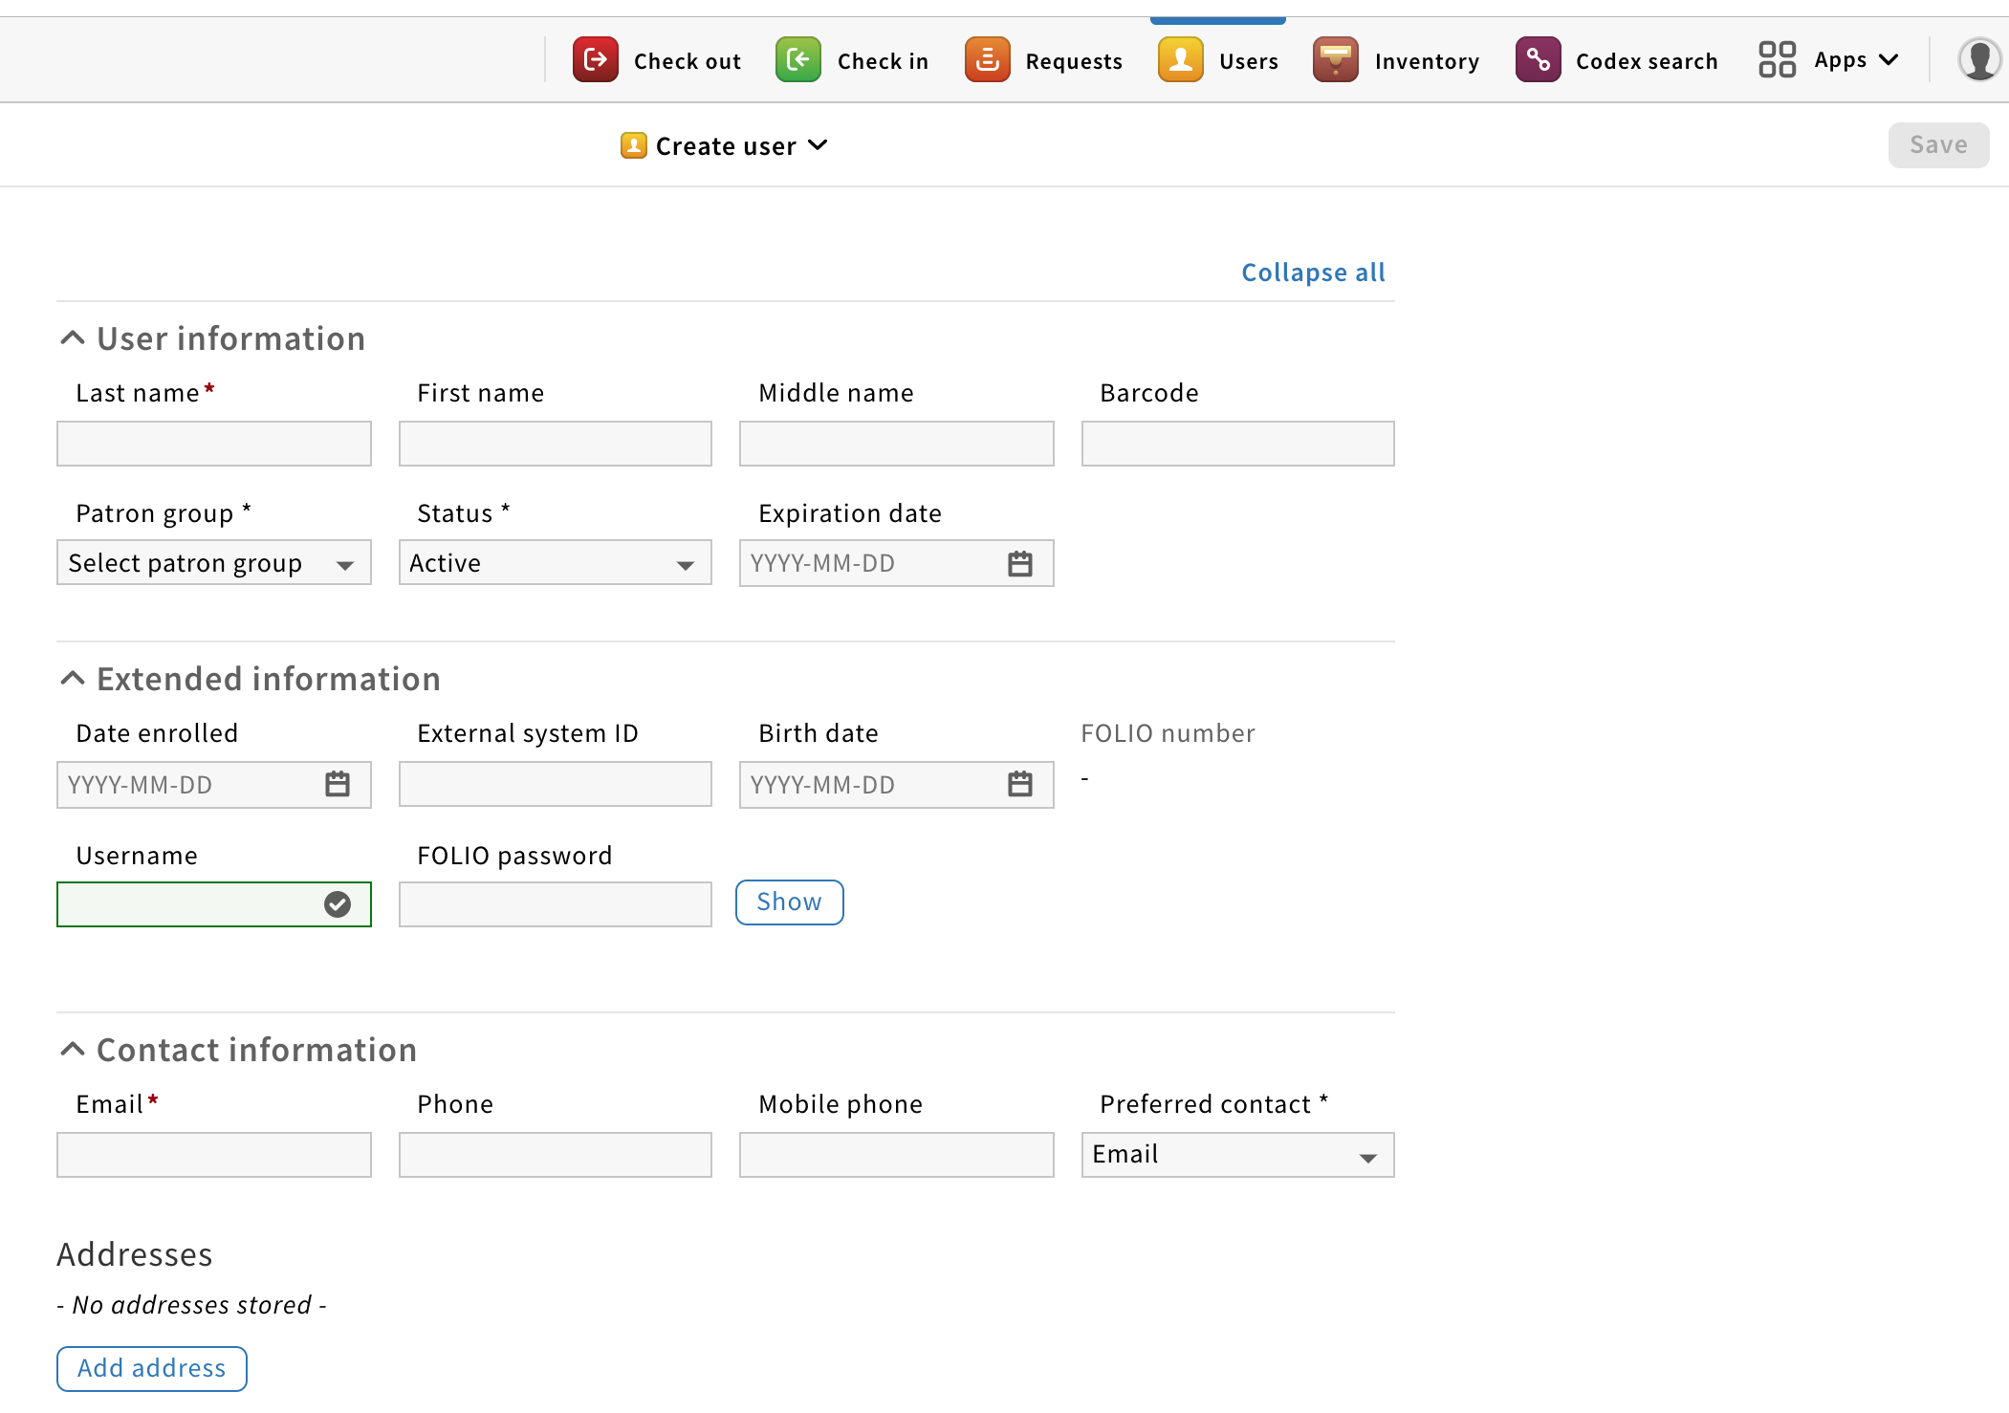

It should look like this:

4. Click on the pencil icon to edit the user you just created and scroll down to User Permissions

5. Click on add “all permissions”

6. Click on Service points

7. Click on add Service points and this box will appear, click the box by Name and everything will be selected, then hit save and close.

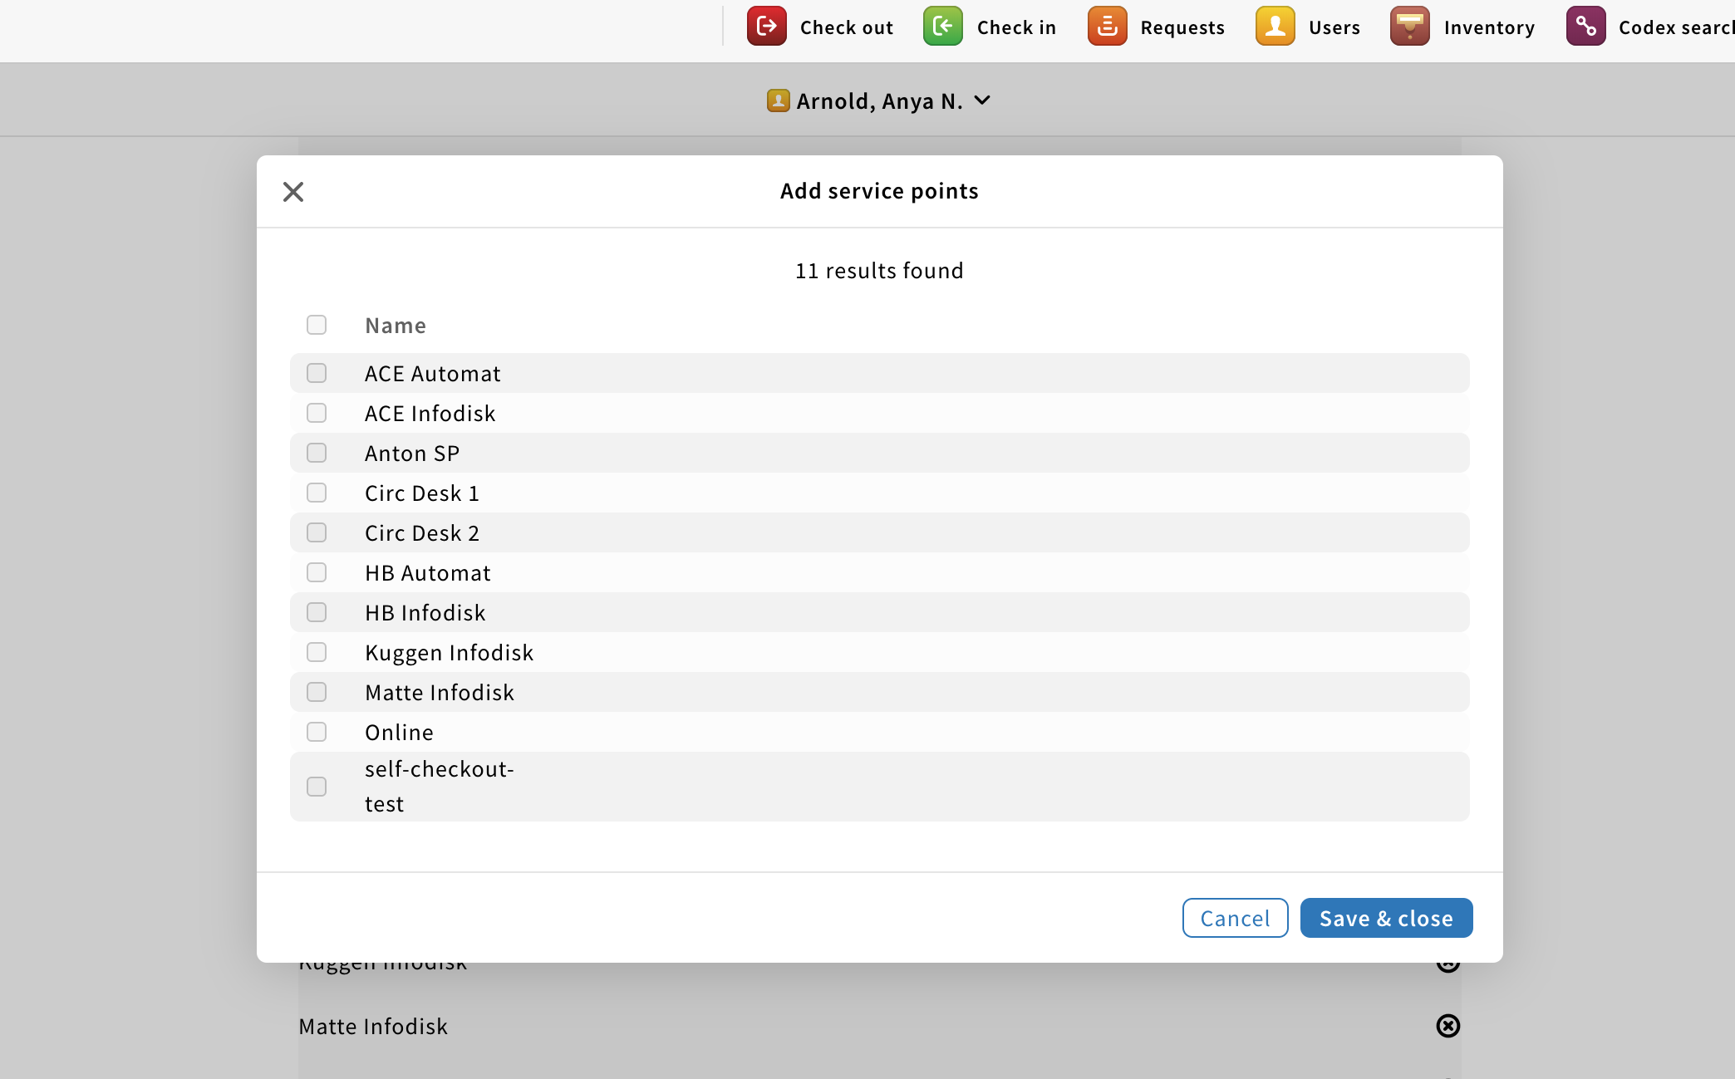

8. Select your preferred service point, for this test use “HB Infodisk”

9. Save your record.

10. Log out of FOLIO.

11. Log in with your new FOLIO user.

Testing- Orders
Open orders app.

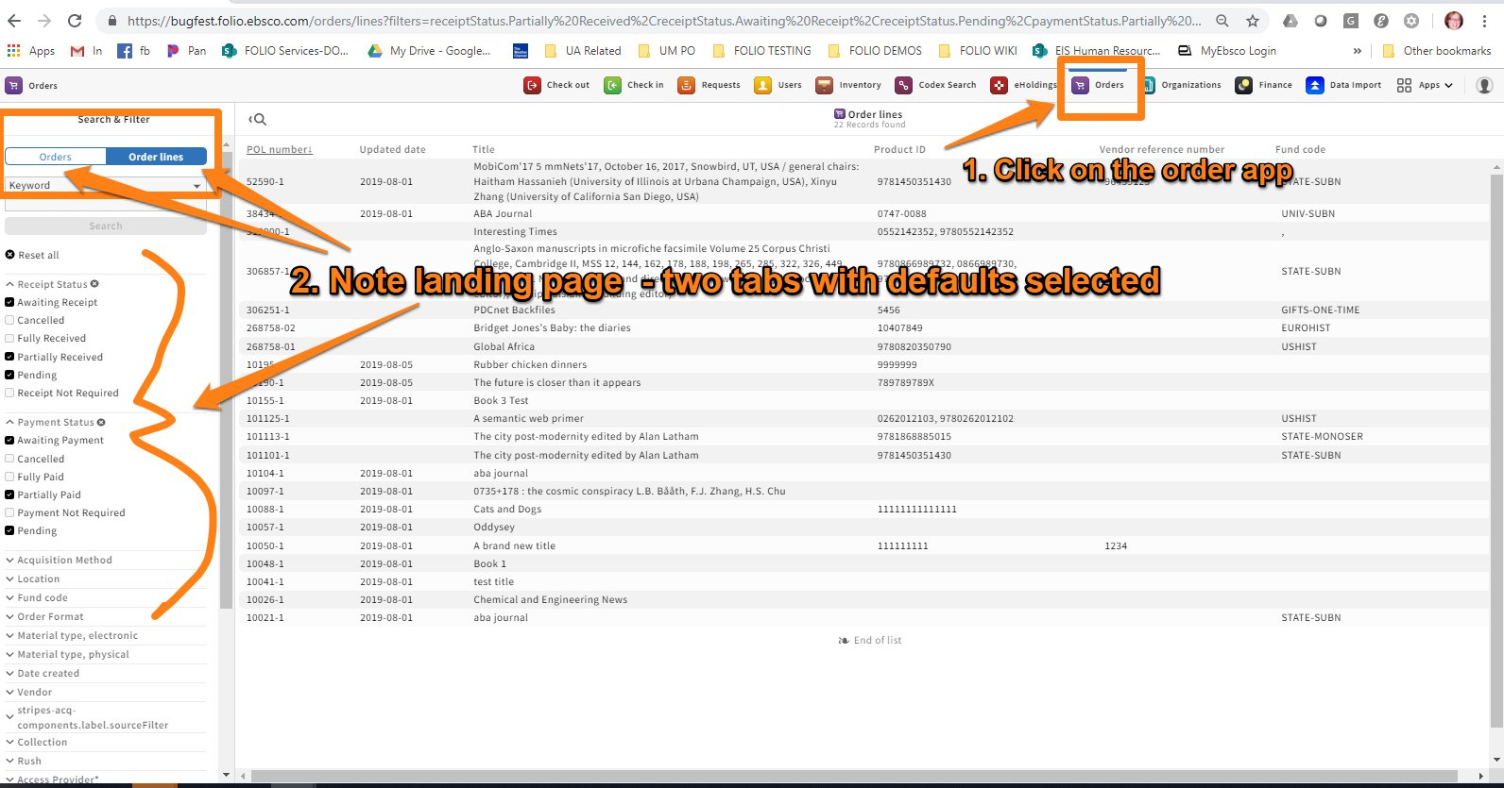

- Create an order - Create the PO – Click NEW on the order tab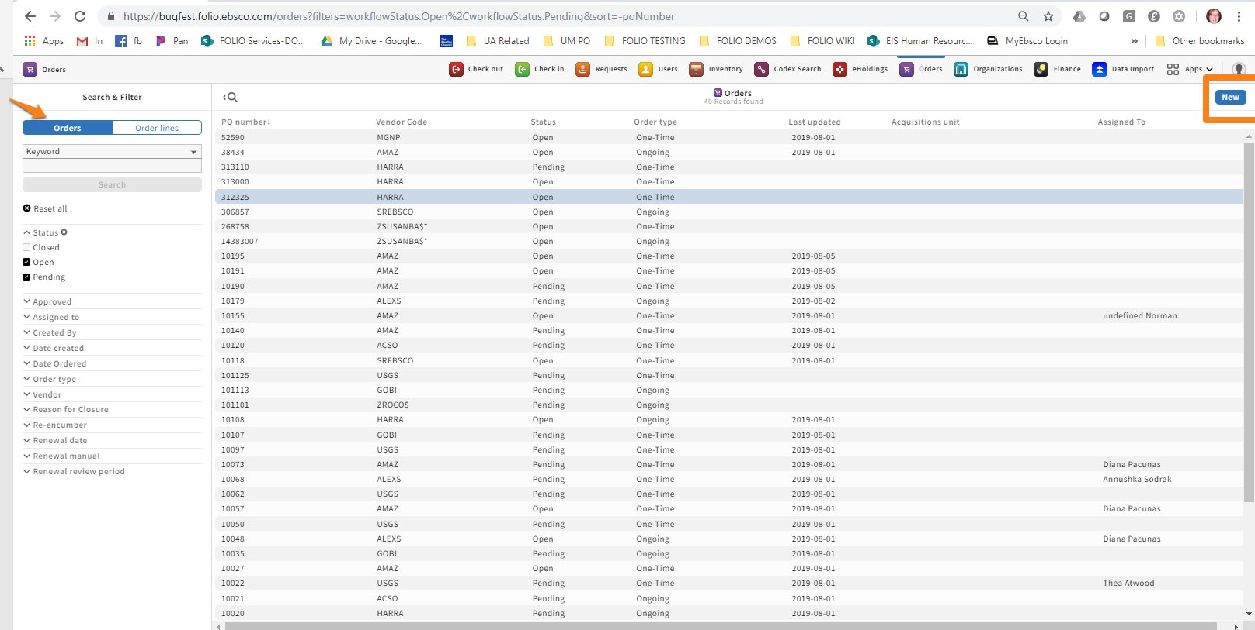
- Fill out required fields. The PO number is automatically assigned. You may add prefix and suffix if you like.
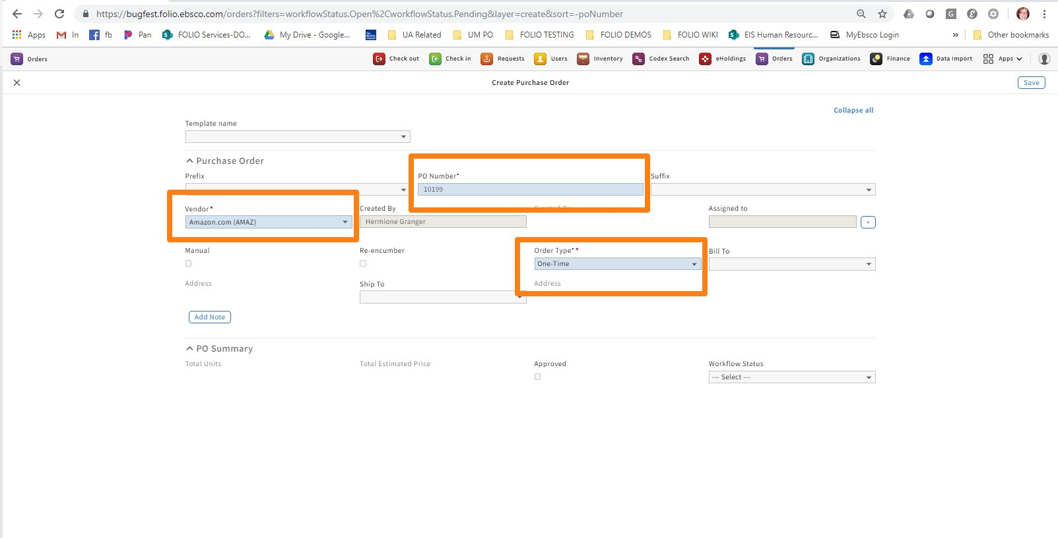
- Save; PO will appear after a second or two; click to add PO line
- PO line is a big record. The first section is “Item details.” Note only title is actually required. 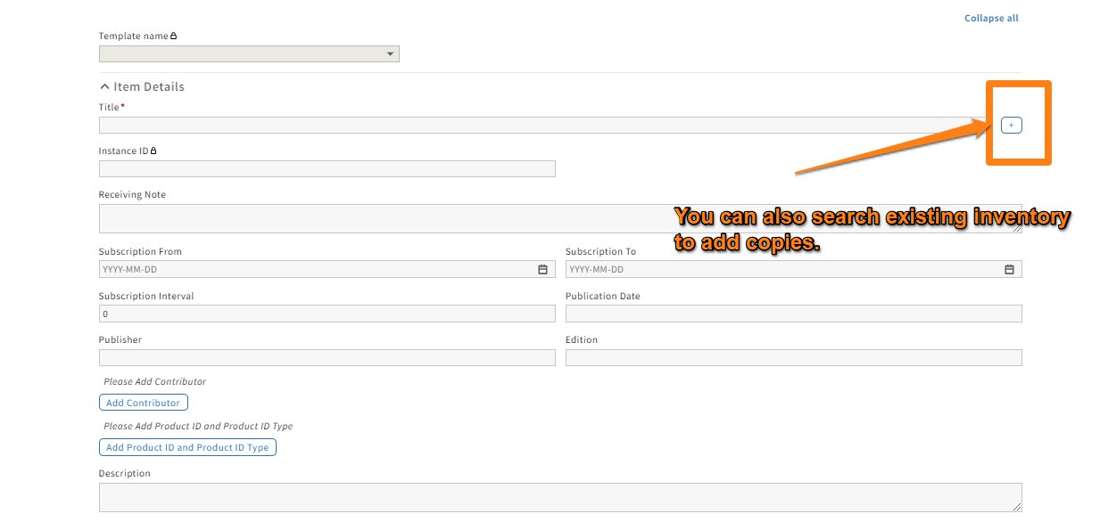. Fill out as many item details as you like.
- Next section is PO Line Details. For this example select a Physical Resource in the Order Format.
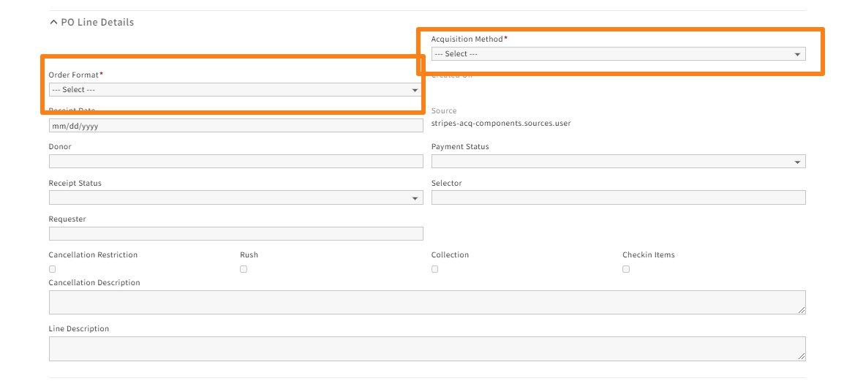
- Cost details is next. Note required fields.
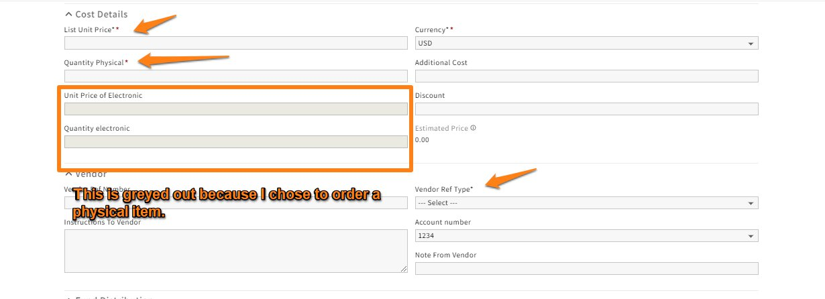
- Vendor – need to select Vendor Ref Type
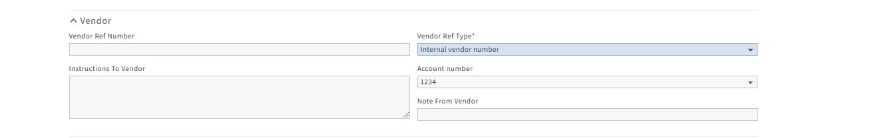
- Fund distribution – skip for this example
- Physical resource details. This is where you select whether or not to create a record in inventory – if you create with item, the item can theoretically be requested.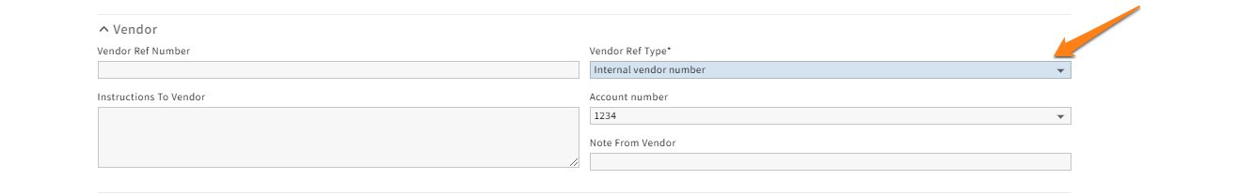
- Adding locations – we have to assign the ordered items to a location, either the same or two different ones.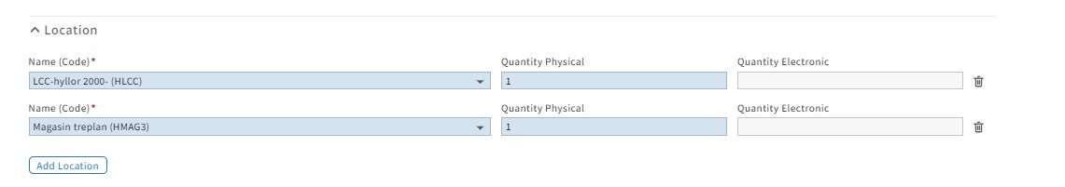
- SAVE

Other order scenarios to try:
- Create an order with at least one order line for a on-going order. (T1435)
- Edit an existing PO in some way. (T1436)
- Edit an existing PO line. (T1437)
- Add an order line to an existing PO. (T1438)
- Close an existing order. (T1439)
- Order more than one copy on a single PO line.
- Open an order to create an instance only.
- Add multiple lines to a PO
A Saved purchase order has a status of PENDING – that means it has not been transmitted to the vendor yet.

SUBMITTING THE ORDER
To change the status from PENDING to OPEN, Search for the PO and click OPEN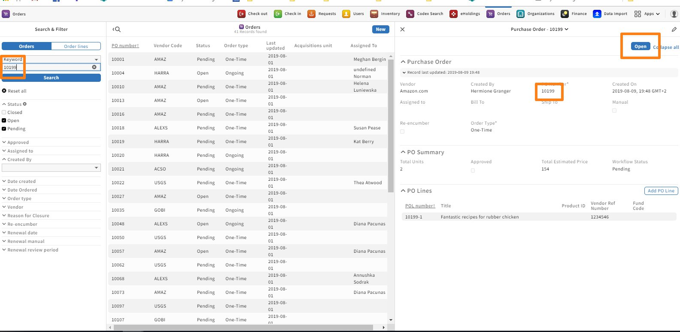
You’ll get an “Are you sure?” message; press Submit.
Pressing SUBMIT will convey the order to the vendor, and change the top action tabs to RECEIVE and CLOSE ORDER. Submitting also triggers the creation of the instance, holding and item (if you’ve chosen that option) in Inventory. At this point, the item appears in inventory with an “on order” status and a hold can be put on it. My order had two copies so two holdings were created.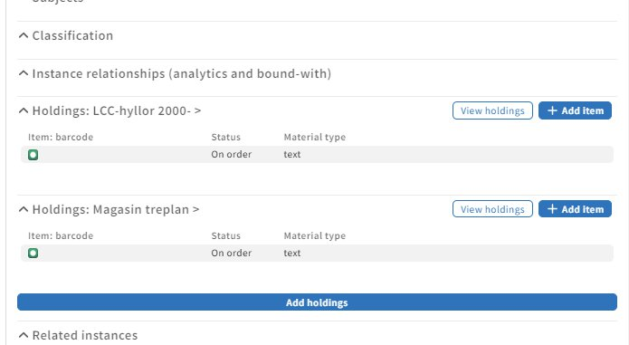

RECEIVING
1.You can search for your order by PO or PO line

2. Click receive. 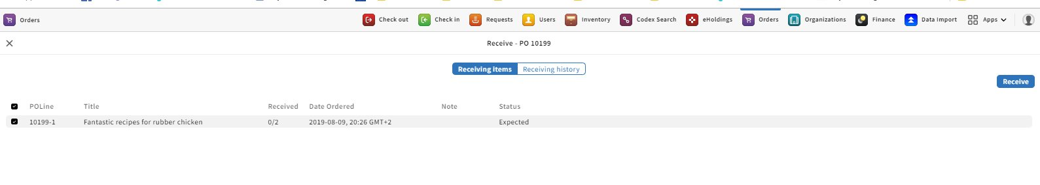
3. Select the line item and receive. You can add barcode and item status is changed to inprocess. You get the chance to review before receiving.
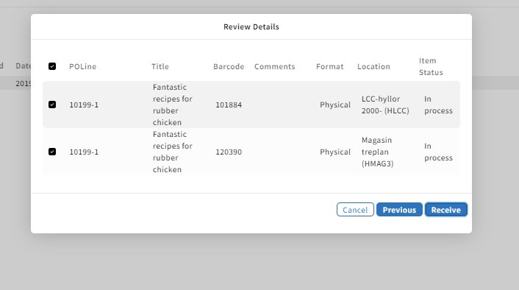
4. Upon saving, you are returned to a screen that shows the items in history.
5. You can then close the order – It will ask for a reason.
6. In inventory, the items now have the status “in-process”.

Other scenarios to try:
  - Receive on a PO with multiple lines
  - Receive an electronic item with instance only
  - Receiving pieces from an order for physical material that is set to create items in inventory. (T1476)
  - Check in pieces from an order and ensure that inventory is created. (T1478)
  - Create a physical order with payment not required and fully received to close the order as complete. (T1479)

Testing- Inventory
Open inventory app.

The Left pane is where search and filter is, as in all FOLIO apps.

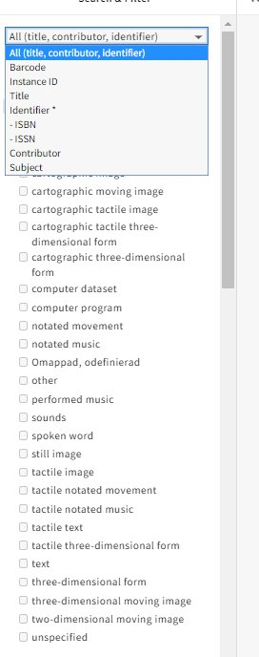
1. Test search field working for combined filter. (T1364)

2. Test search field working for a single filter: title, identifier, subject. (T1365)

3. Test additional filters located below main search field. (T1366)

4. Create new instance with “add new”. (T1367)
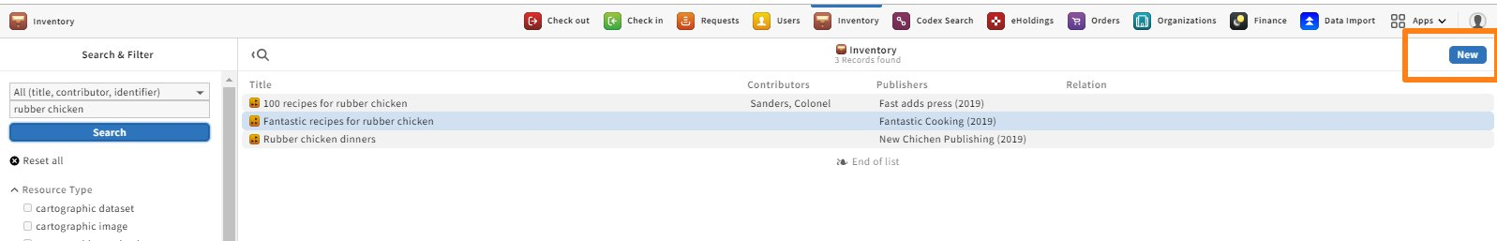
Or
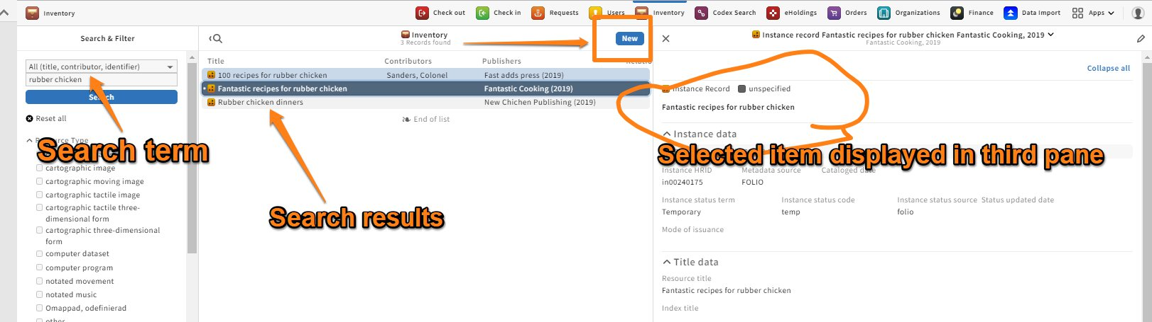

5. Create new instance with “Duplicate”. (T1368)
