Hello Mr. Axel Dörrer, we are very pleased to receive your questions about our technical information.

We currently don’t have a production environment yet. And we are working on it. The main goals is to design a more larger cluster of FOLIO in order to support our future services.

About our tech structure, we will introduce it in two parts:the software and hardware structure.

- About the software structure
We defined three layers of the software structure: folio basic layer, application model layer, user layer. The folio basic layer are the basic modules of folio, such as OKAPI, messaging services,logging services, server monitor, databases. The application layer is the business logic of our services. Such as User modules, circulation modules, collection modules, discovery modules. The user layer is the endpoint user including our readers, librarian, self-check device, third party applications.
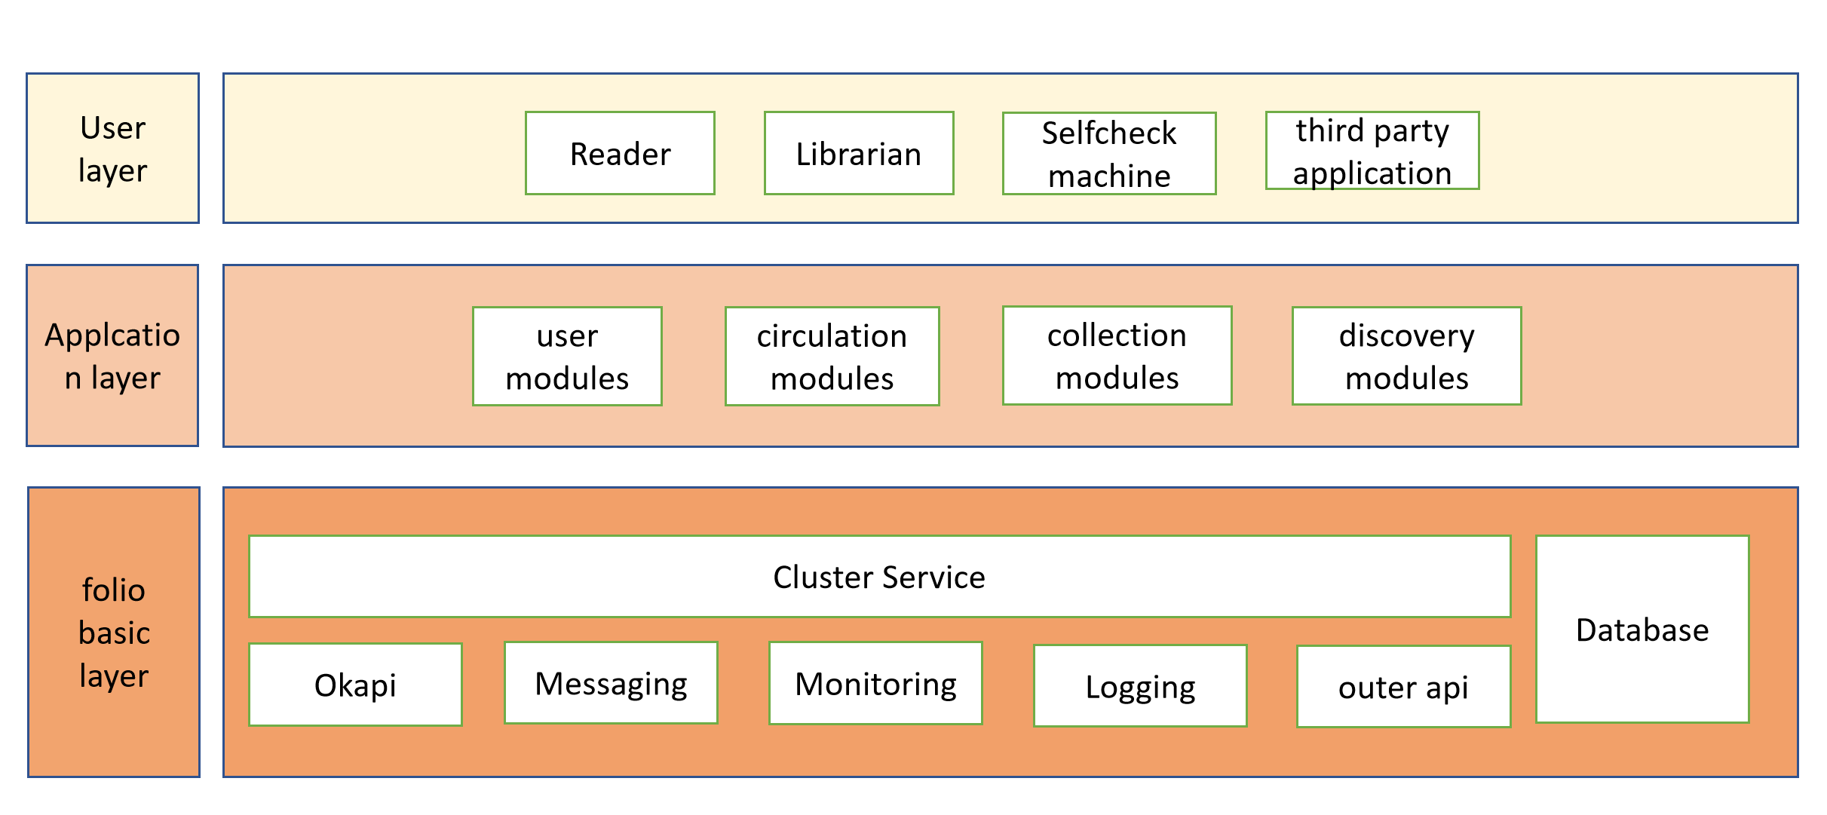
- About the hardware structure
We are implementing DevOps and other ideas in our R&D. We are using GitLab as a local code repository, use Jenkins+Maven+Npm+Docker to build the code, and using Nexus to manage as well as deploy to a UAT environment.
We are now using single Docker to run the test environment. As for the production environment, Kubernetes may be the answer.
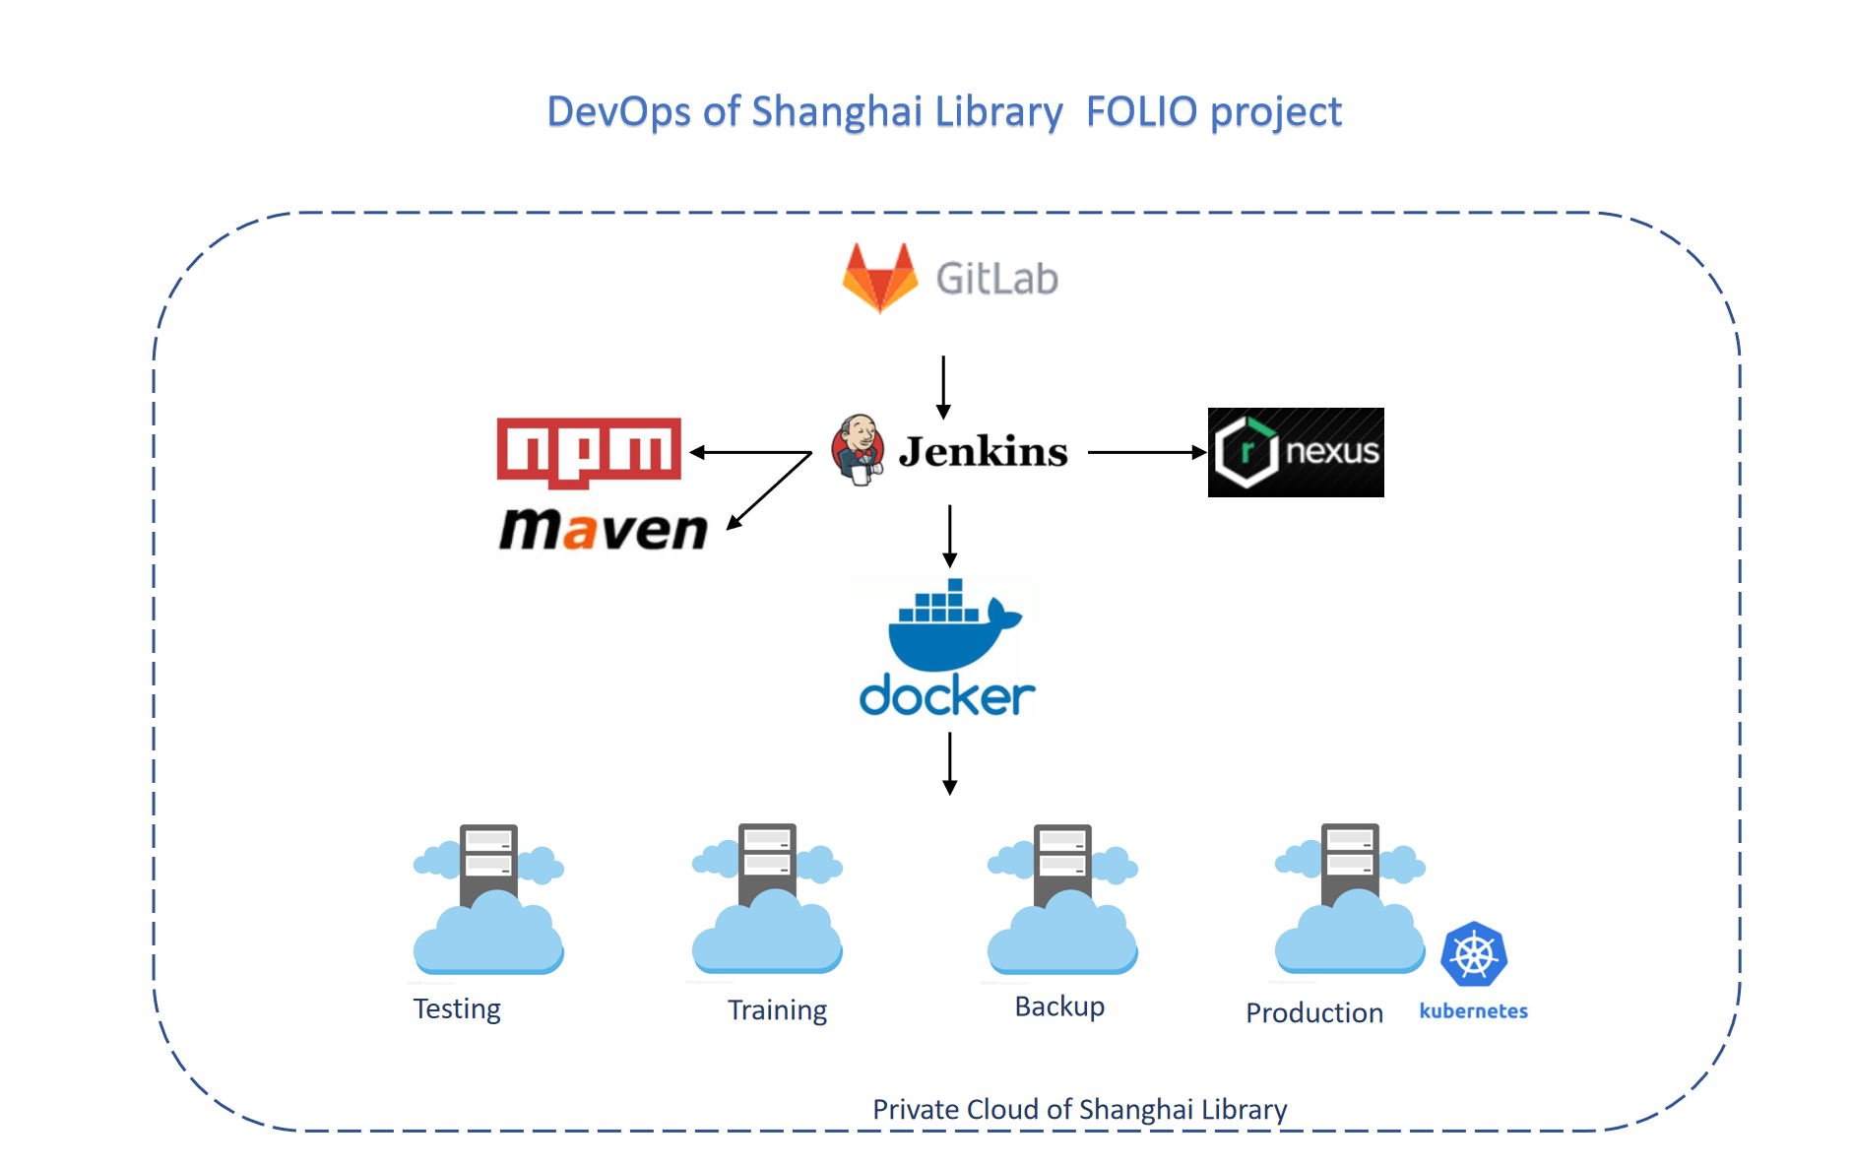
These are the basic information. We wish it will be helpful to you. We will continue to share our progress and experience . Thank you.

