Problems with the limit to the maximum amount of data displayed in settings

1、Screenshots
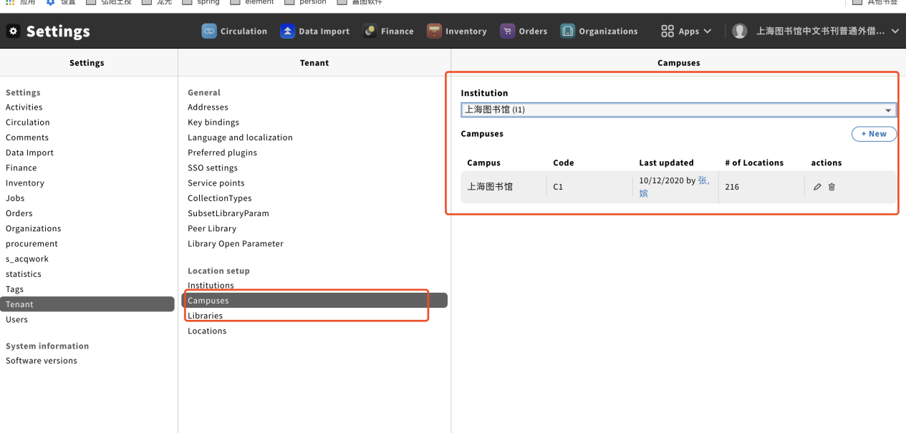
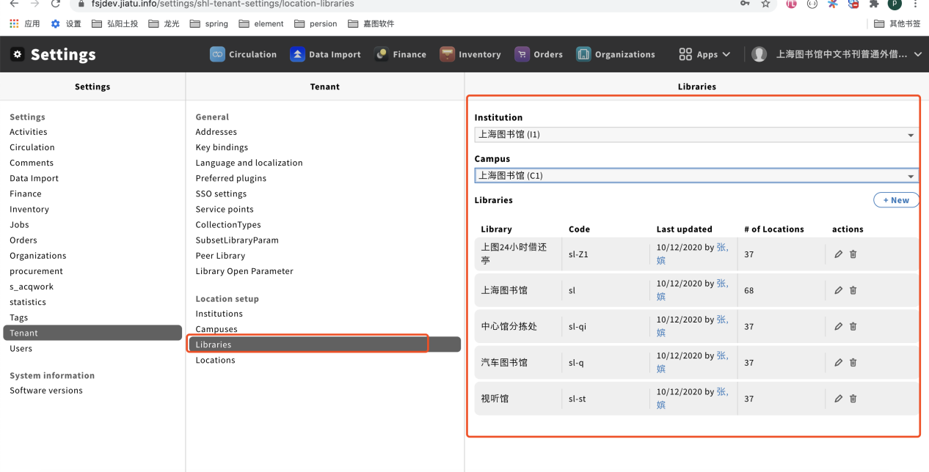
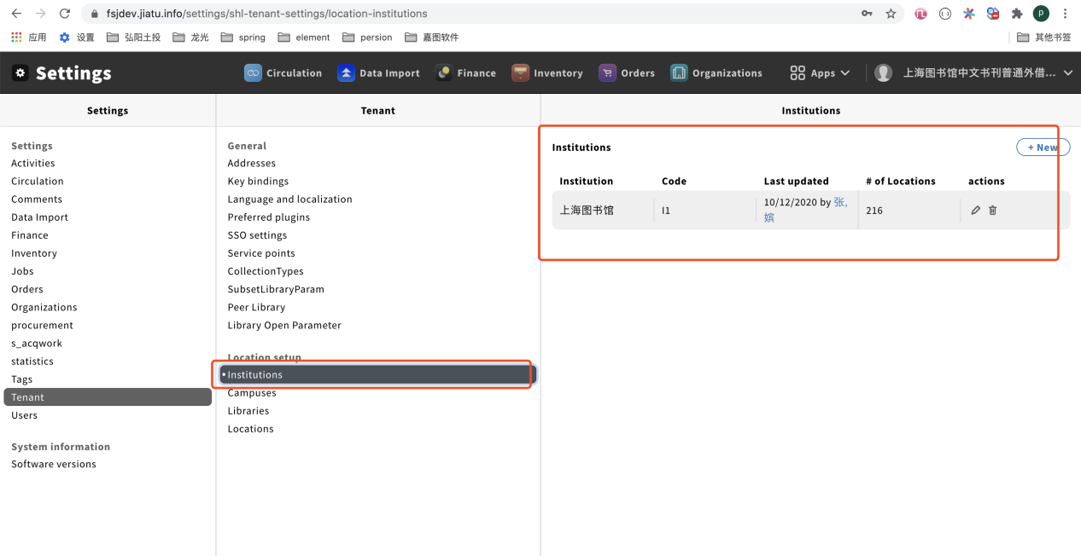
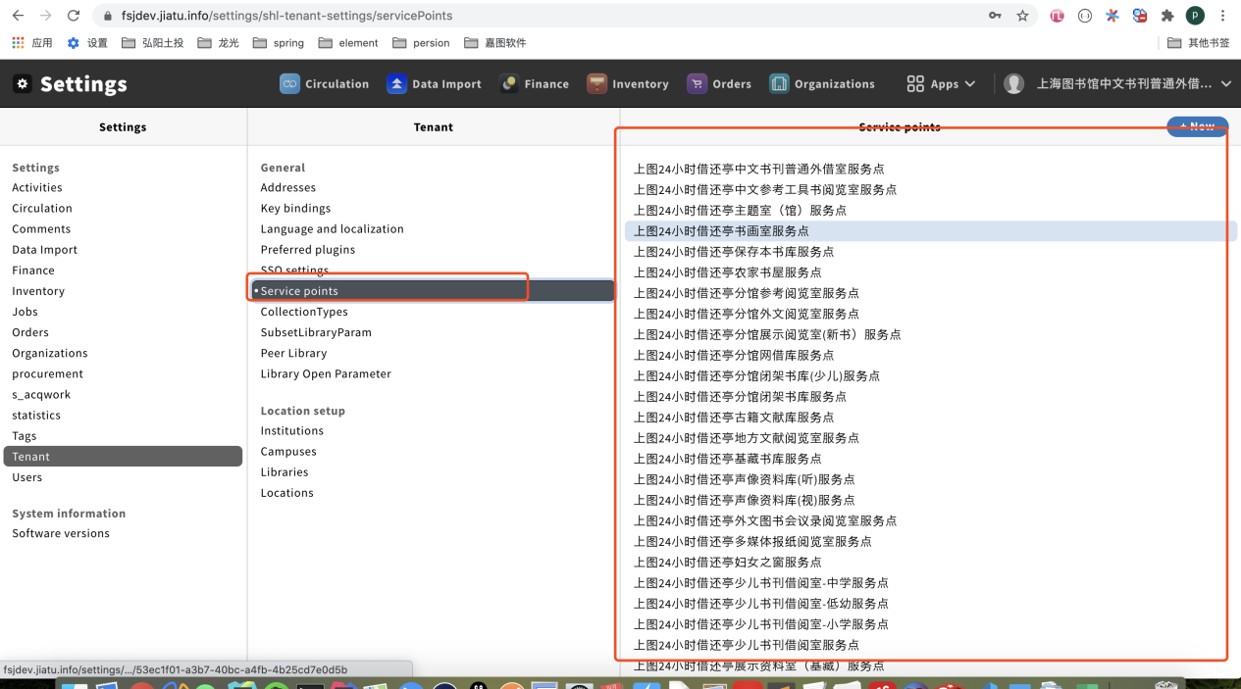

- Problem #1：
In Settings->Tenant->Campuses/Libraries/Institutions/Locations/Service points, a maximum of 3000 items can be displayed. Shanghai Library wants to make this limit configurable in order to load more items.
在设置-租户-馆址中，如果Library和location数量超过3000个，FOLIO现在有limit 3000而不能显示全部记录，希望这个limit能配置

- Problem #2：
On the aforementioned interfaces, folio prefetches all parameters in advance. When there are many parameters, it takes a long time to initialize the pages. It would be ideal to load them interactively with multiple steps, e.g. if we click on a parameter, then only the subordinate parameters will be read, as shown in the second screenshot, we first request institution, then campus, and at last libraries. This will avoid loading all the data at once.
在上述界面中， FOLIO现在预先一次性读取全部参数，如果参数数量很多，页面初始化时间太长，希望能点击某个参数，实时读取此参数下属的参数。如截图2中，institution选择之后再请求对应的Campus，选择了Campus了之后再请求对应的 Libraries。这样可以避免一次加载全部数据

- Solutions tried (已尝试方法)
The interfaces crashed when the limit was changed from 3000 to 20000.
将3000条限制扩大到20000条，结果界面崩溃

- Temporary solution on plan (计划采用的临时方案)
Redo the interface managing circulation rules. Create a new interface to accomplish the tasks.
以目前重做流通规则管理界面的方式，新建界面、完成相应的业务。

