FOLIO Module Server Monitor(模块服务器监控):

CPU usage:
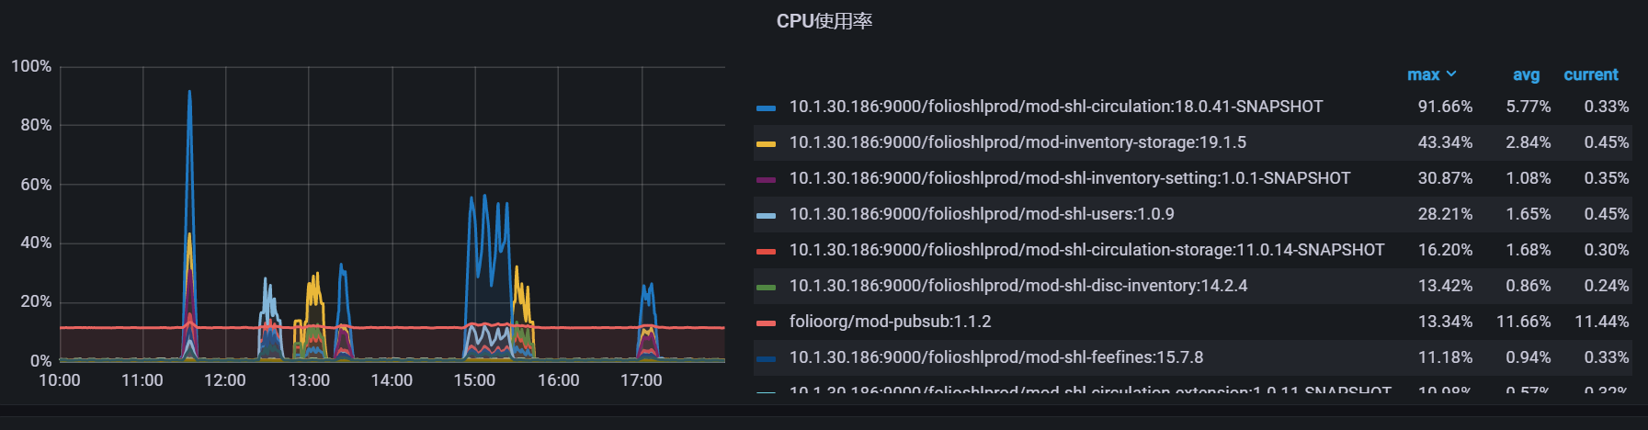
Memory usage:
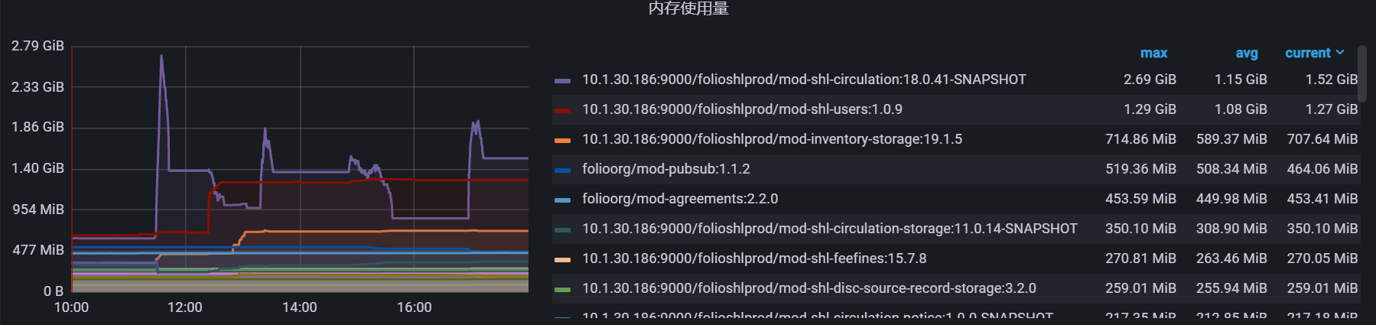
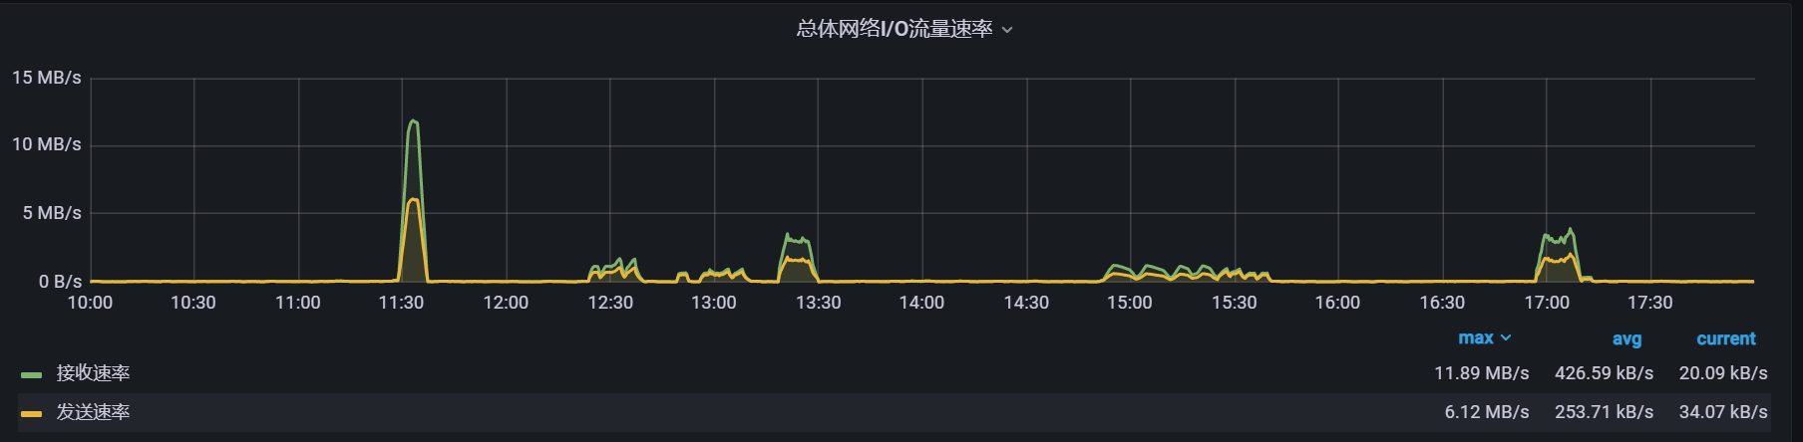
Overall network traffic rate:

DB Server Monitor(数据库服务器监控)：
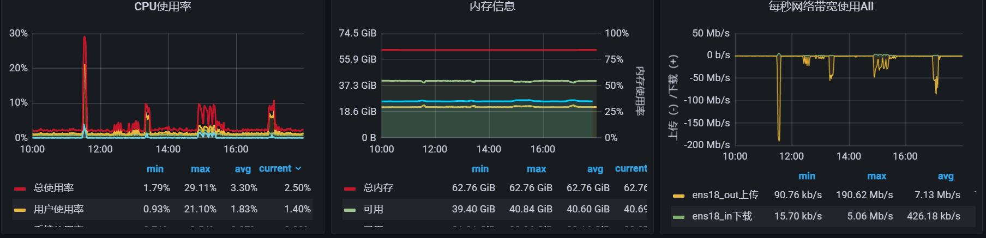
CPU usage (left); Memory usage(middle); Network bandwidth traffic per second (Right)
Disk read and write rate (left)；The percentage of time spent in I/O operations per second (middle)； Time spent reading and writing each IO (ref: less than 100ms) (beta) (Right)
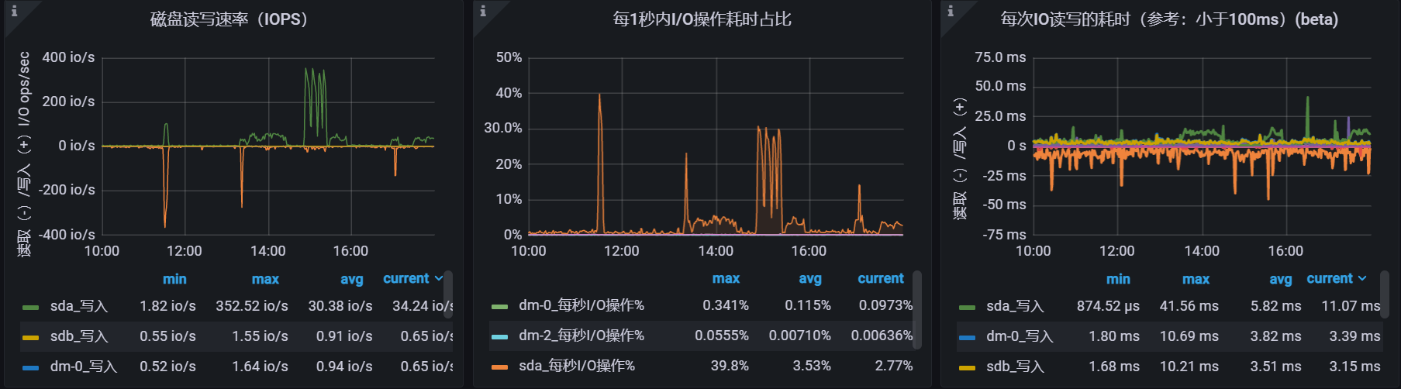

Period (时间段) | Action (操作)
11：28--11：38 | Checkout (借出)
12：23--12：33 | Sip2 query stress test (Sip2查询压测)
12：55--13：08 | Sip2 query stress test (Sip2查询压测)
13：18--13：28 | Checkin (还回)
14：51--15：36 | Sip2 query stress test (Sip2查询压测)
16：56--17：06 | Checkin (还回)

Check-out and check-in test results at 30 concurrency:
The average loan time is 1.13s
The average return time is 13.9s
借出和还回在30并发时测试结果：
借出平均时间为1.13s
还回平均时间为13.9s

Check-out and check-in test results at 20 concurrency:
The average loan time is 0.50s
The average return time is 0.80s
借出和还回在20并发时测试结果：
借出平均时间为0.50s
还回平均时间为0.80s

